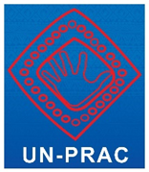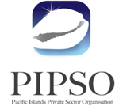**Code of Conduct**

**for Pacific Islands Private Sector Organisation (PIPSO) and National Private Sector Organisation Organisations (NPSOs)**

1. A commitment to ethical behavior and preventing corruption will be at the core of our NPSOs and PIPSO.

2. We will not engage in unethical behaviour when dealing with members, government officials, stakeholders, political parties, our own employees and employees of other organisations and businesses.

3. We will report to the appropriate authority any bribery, extortion or solicitation and embezzlement in contravention of the relevant laws and legislations of our countries.

4. Occurrences of gift-giving and receiving will be dealt with transparently through a publicly available register.

5. Conflicts of interest must be disclosed and perceptions of conflicts will be dealt with transparently.

6. Relationships between board members, staff and members will be based on fairness with a commitment to transparent recruiting, merit and training, which avoids any corruption or favouritism.

7. We will protect any data collected against mishandling and fraud, collect personal information only as needed, and respect the preferences of stakeholders, members and staff regarding the use of their information.

8. Embracing free enterprise and mutual support in the spirit of the Sustainable Development Goals, we will operate so that everyone can benefit from vibrant business activity and the ensuing economic growth and stability.

**Accompanying notes to the Code of Conduct and E-learning Module:**

The Pacific Islands Private Sector Organisation (PIPSO) seeks to create and sustain an ethical business climate for its member National Private Sector Organisation Organisations (NPSOs) and the community by adopting a Code of Conduct.

PIPSO encourages its members to incorporate the principles and practices outlined here in their individual codes of ethics which will guide their relationships with their members, governments, stakeholders, their own and others’ employees and volunteers, customers, clients and suppliers. This Code should be prominently displayed at all NPSO locations and may be incorporated into marketing materials. PIPSO believes that its members should use this Code as a model for the development of their own member organizations' business codes of conduct. While this Code applies to the NPSO, individual business operators may choose to adapt the Code for their own businesses.

This Code is a statement of principles to help guide decisions and actions based on respect for the importance of ethical business standards in the community. PIPSO believes the adoption of a meaningful Code of Conduct is the responsibility of every business and professional organization.

NOTES TO SPECIFIC SECTIONS OF THE CODE:

***1. A commitment to ethical behavior and preventing corruption will be at the core of our NPSOs and PIPSO.***

This can be achieved through good practices such as:

1.1 Establishing strong political will by the board and the management of the NPSO to combat corruption in the private sector.

1.2 Ensuring that the members, board, management, employees and volunteers have personal ownership of this Code and abide by it at all times.

1.3 Organizing and coordinating anti–corruption training for employees and members.

1.4 Abiding by all written agreements and verbal representations, fulfilling contracts signed and agreements reached and correcting mistakes as quickly as possible.

This is aligned to Sustainable Develoment Goal (SDG) 16, Promote peaceful and inclusive societies for sustainable development, provide access to justice for all and build effective, accountable and inclusive institutions at all levels.

***2. We will not engage in unethical behaviour when dealing with members, government officials, stakeholders, political parties, our own employees and employees of other organisations and businesses.***

Such unethical behavior includes but is not limited to:

Bribery, which is giving, receiving or promising of money or favors of any kind in order to influence the decision or action of an individual in a position of trust;

Extortion or Solicitation - demanding a bribe, which may be followed by a threat if the demand is refused;

Embezzlement - theft or misappropriation of funds and/or assets belonging to an NPSO/PIPSO by an employee/member of the NPSO/PIPSO;

Laundering proceeds from illegal activities - hiding, concealing, covering up the beginning, source, position, movement or ownership of a property while being fully aware that the property is a proceed of crime.

This is fully aligned to SDG 16.

***3. We will report to the appropriate authority any bribery, extortion or solicitation and embezzlement in contravention of the relevant laws and legislations of our countries.***

The receipt of gifts or favours by staff and officeholders of NPSOs from stakeholders can be seen as improper inducement. Gifts and favours must not be solicited. Gifts of money must never be accepted. Reasonable small tokens [below US$20] and hospitality may be accepted provided they do not place the recipient under any obligation, are not capable of being misconstrued and can be reciprocated at the same level. Any offer of gifts or favours of unusual size or questionable purpose should be reported to the CEO of the NPSO immediately. This is also aligned to SDG 16 and Goal 10, Reduce inequality within and among countries.

***4. Occurrences of gift-giving and receiving will be dealt with transparently through a publicly available register.***

4.1 Gifts Register - Gifts and entertainment that are given or received should be recorded in a gift register and reported to the Board of the NPSO. Each NPSO and PIPSO needs to adopt a written gifts policy.

4.2 Entertainment - may only be offered to stakeholders in the course of business provided it is reasonable and modest and neither influences the recipient’s objectivity nor could be construed as a means to make the recipient feel obliged to act in accordance with the wishes of the NPSO.

4.3 Donations to political parties and charitable organisations may be arranged on the condition that it is transparent and in accordance with existing laws and legislations of the country; it does not influence the recipient’s objectivity and should not be interpreted as a means to make the recipient feel obliged to act in accordance with the wishes of the NPSO.

This is aligned to SDG 10 and SDG 16.

***5. Conflicts of interest must be disclosed and perceptions of conflicts will be dealt with transparently.***

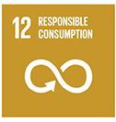While many people in small Pacific countries have interests in common which would usually not lead to conflicts of interest, full transparency is achieved by staff and members declaring any potential issues of personal interest and interests of immediate and extended families that may directly affect the operations of the NPSO to the CEO of the NPSO (for staff) and Chair (for board members and the CEO). This aligned to SDG 10, SDG 12 (relating to transparent procurement) and SDG 16.

***6. Relationships between board members, staff and members will be based on fairness with a commitment to transparent recruiting, merit and training, which avoids any corruption or favouritism.***

6.1 Human Resources - NPSOs are encouraged to formulate Human Resource policies that outline proper, efficient, fair and transparent recruitment, promotion, training, performance evaluation and remuneration processes for staff that will avoid corruption and nepotism.

6.2 Finance And Accounting - NPSOs must establish and maintain appropriate, accurate and transparent financial records and reporting mechanisms following the relevant accounting and financial reporting standards both locally and internationally. NPSOs should strive to conduct annual audits of their financials to prevent corruption.

This section is very much aligned with SDG 8, Promote sustained, inclusive and sustainable economic growth, full and productive employment and decent work for all, and also SDG 5, Achieve gender equality and empower all women and girls, and Goal 10, Reduce inequality within and among countries; SDG 12, Ensure sustainable consumption and production patterns, includes a “Target 12.7 Promote public procurement practices that are sustainable, in accordance with national policies and priorities”.

***7. We will protect any data collected against mishandling and fraud, collect personal information only as needed, and respect the preferences of stakeholders, members and staff regarding the use of their information.***

This relates to the confidential nature of the private details of members being provided for a specific use and any survey information which is collected, including data being fed into national statistical plans. This is aligned to SDG 10 and SDG 16 and SDG 17 (Target 17.18 relating to confidential data).

***8. Embracing free enterprise and mutual support in the spirit of the Sustainable Development Goals, we will operate so that everyone can benefit from vibrant business activity and the ensuing economic growth and stability.***

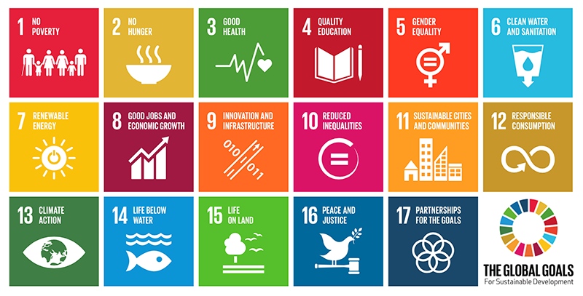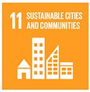This is aligned to SDG8, SDG9, Innovation and Infrastructure, SDG 11, Make cities and human settlements inclusive, safe, resilient and sustainable, SDG 12, Ensure sustainable consumption and production patterns, (which includes a “Target 12.7 Promote public procurement practices that are sustainable, in accordance with national policies and priorities”) and SDG 16.

**E-learning Module**

PIPSO (Pacific Islands Private Sector Organisation) Code of Conduct : this Code of Conduct was endorsed by the PIPSO Board at its July 2017 meeting.

NPSO members can opt to use this e-learning module as a self-paced exercise but it is important that a group workshop plus official meeting completes the process so as there is shared understanding of the Code and official adoption.

**1. Individual members of the NPSO digest the material in this self-paced e-learning module, recording issues they need elaboration on or policy issues they want to discuss further with other NPSO colleagues to achieve consensus.**

**2. There are four templates on key issues at the end of this module which your NPSO should discuss as Next Steps.**

**2. The NPSO schedules a group meeting discuss and adopt the NPSO Code of Conduct. The NPSO is encouraged to contact PIPSO and UN-PRAC and invite a facilitator from UN-PRAC or PIPSO to assist in the adoption workshop.**

**3. If consensus is achieved at the workshop, the recommendation is forwarded to the NPSO board and then the NPSO AGM for official adoption.**

**4. Ensure you determine a review date for the Code and provide for any training of new members.**

**Reference Material**

**PIPSO and UN-PRAC OUTCOME:**

1. The recommendation in PIPSO’s 2013 Guidelines for PIPSO and member National PSOs (NPSOs) to draft a template Code of Conduct is activated;
2. A template gifts and hospitality policy is addressed;
3. The Code of Conduct and gifts policy is evaluated and fine-tuned first by UN-PRAC and PIPSO staff and then adopted at a PIPSO/UN-PRAC training workshop to ensure ownership and understanding.

**BACKGROUND:**

The UN Pacific Regional Anti-Corruption (UN-PRAC) Project supported by the UN Development Programme (UNDP) and the UN Office on Drugs and Crime (UNODC) has a mandate to engage Pacific Islands private sector organisations and members in the fight against corruption.[1]

The Pacific Islands Private Sector Organisation (PIPSO) is the premier private sector representative body in the Pacific Islands region. Its members are comprised of the national private sector organizations of the 14 Pacific Island Forum Countries. One of PIPSO’s guiding principles in its Strategic Plan 2016-19 is “Integrity: We conduct business with honesty and integrity and making decisions to ensure future stability and sustainability.” [2]

The private sector’s vital role in the fight against corruption is emphasized in the United Nations Convention against Corruption (UNCAC). Article 12 states that: “Each State Party shall take measures, in accordance with the fundamental principles of its domestic law, to prevent corruption involving the private sector, enhance accounting and auditing standards in the private sector and, where appropriate, provide effective, proportionate and dissuasive civil, administrative or criminal penalties for failure to comply with such measures.” Article 21 deals directly with bribery in the private sector and Article 22 addresses embezzlement of property in the private sector.

At the fifth session of the Conference of State Parties (CoSP) for UNCAC, held in Panama from 25 to 29 November 2013, the Conference adopted resolution 5/6, entitled “Private sector”. The resolution urged States parties to take prevention measures, including by strongly encouraging them to raise awareness within the whole private sector on the need to establish and implement appropriate anti-corruption ethics and compliance programmes.

UNODC also finalized “An Anti-Corruption Ethics and Compliance Programme for Business: a Practical Guide” that was launched in Panama at the fifth session of the Conference. In September 2015, UNODC acted as an organizing partner for the United Nations Private Sector Forum 2015, which focused on the role of the private sector in implementing the sustainable development goals. [3]

Since May 2015, within the context of the United Nations Pacific Regional Anti-Corruption (UN-PRAC) Project, PIPSO, UNODC and UNDP have been working closely together not only to raise awareness of efforts to combat corruption in the private sector, but also to enable the project to take on board the concerns of private sector representatives who may face corruption. A first private sector workshop was held with the PIPSO member organization in Tonga in June 2015. This was the first event that enabled local business people to become aware of corruption-reporting avenues available to them in Tonga. UN-PRAC followed up the Tonga trial with a full workshop for all PIPSO delegates at the PIPSO AGM conference in July, 2015.

**Implementation of PIPSO Code of Conduct template**

A desk review by UN-PRAC of best practice Codes of Conduct for private sector organisations, cognizant of current efforts in PIPSO member organisations to adopt their own Codes, produced a draft Code of Conduct as a starting document for UN-PRAC and PIPSO staff review and discussion, prior to presentation at the 2017 mid-year PIPSO AGM. Following input from PIPSO board members and NPSOs, the Code was revised into this final version.

Attached to the Code are references to best practices and supporting material to ensure compatibility with member organisations while developing a best practice Code of Conduct for PIPSO suitable for a PIPSO workshop. The key advantage of undertaking a subsequent training workshop, which includes not only experts on codes but also South-South and Pacific learning, is being able to reinforce how a successful Code of Conduct must be a living document; that there needs to be a visible and active commitment of any organization’s senior management towards zero-tolerance of corruption and the development and implementation of an anti-corruption programme. This Code includes succinct sections on gifts and hospitality, which may negate the need for a separate gifts policy being developed.

**Reference material to inform review of the Code and workshop discussion:**

“Building Resilient NPSOs” (June 2013) guidelines section is on Governance:[4]

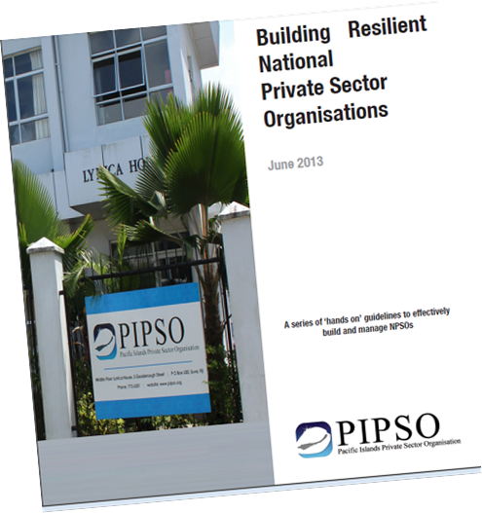

* 1. **Avoiding corruption and conflict of interest**

Avoiding corruption and conflict of interest is crucial to sound governance in any organisation. The policies of an NPSO can take active measures to preclude malpractice in its operations.

The Board should draft a code of conduct for the organisation, which would be used to guide management behaviour, and to evaluate their performance.

Another way to avoid corruption and conflict of interest is to develop internal checks and balances. Many of the recommendations in this guide are based on the need to develop a balance of authority and oversight between the various core institutions of governance in an NPSO.

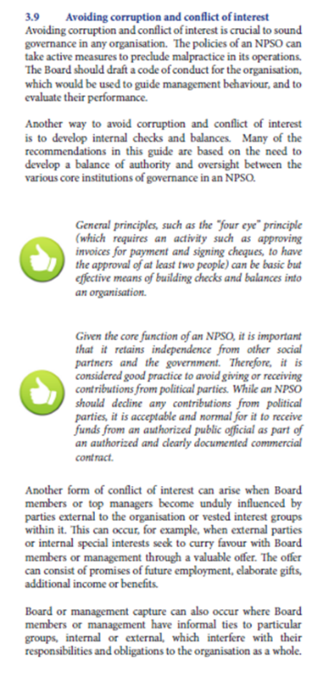General principles, such as the “four eye” principle (which requires an activity such as approving invoices for payment and signing cheques, to have the approval of at least two people) can be basic but effective means of building checks and balances into an organisation.

Given the core function of an NPSO, it is important that it retains independence from other social partners and the government. Therefore, it is considered good practice to avoid giving or receiving contributions from political parties. While an NPSO should decline any contributions from political parties, it is acceptable and normal for it to receive funds from an authorized public official as part of an authorized and clearly documented commercial contract.

Another form of conflict of interest can arise when Board members or top managers become unduly influenced by parties external to the organisation or vested interest groups within it. This can occur, for example, when external parties or internal special interests seek to curry favour with Board members or management through a valuable offer. The offer can consist of promises of future employment, elaborate gifts, additional income or benefits.

Board or management capture can also occur where Board members or management have informal ties to particular groups, internal or external, which interfere with their

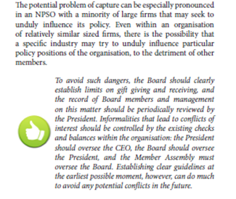responsibilities and obligations to the organisation as a whole. The potential problem of capture can be especially pronounced in an NPSO with a minority of large firms that may seek to unduly influence its policy. Even within an organisation of relatively similar sized firms, there is the possibility that a specific industry may try to unduly influence particular policy positions of the organisation, to the detriment of other members. To avoid such dangers, the Board should clearly establish limits on gift giving and receiving, and the record of Board members and management on this matter should be periodically reviewed by the President. Informalities that lead to conflicts of interest should be controlled by the existing checks and balances within the organisation: the President should oversee the CEO, the Board should oversee the President, and the Member Assembly must oversee the Board. Establishing clear guidelines at the earliest possible moment, however, can do much to avoid any potential conflicts in the future.

**UNCAC:**

Article 12 is the major focus on the Private Sector in the UN Convention Against Corruption (UNCAC), of which 11 of PIPSO’s national association Governments have signed. Other areas of UNCAC that are directly relevant to the private sector include:

* public procurement (article 9); money-laundering (article 14);
* criminalization of offences of corruption (articles 15-19, 21-25);
* liability of legal persons (article 26); protection of witnesses, experts and victims (article 32); protection of reporting persons (article 33);
* consequences of acts of corruption (article 34); cooperation with law enforcement authorities (article 37);
* cooperation between national authorities and the private sector (article 39); and bank secrecy (article 40).

Businesses can proactively combat corruption through implementation of principles in the UN Convention against Corruption (UNCAC).[5]

UNODC’s “An Anti-Corruption Ethics and Compliance Programme for Business: A Practical Guide”,[6] advises: Senior management must put the “tone from the top” into action, ensuring that zero-tolerance of corruption and the supporting detailed policies and procedures are understood by all employees and relevant business partners.

The training workshop for PIPSO during its AGM explored implementation of a Code through practical actions, such as recommended in the guide – “Joining a voluntary initiative, such as the United Nations Global Compact, World Economic Forum Partnering Against Corruption Initiative (PACI), Extractive Industries Transparency Initiative (EITI), Construction Sector Transparency Initiative (CoST)”; etc Implementation workshops for NPSOs wanting to adopt this Code could also incorporate some of the video presentations from UNODC on developing a Gifts/Hospitality policy if a stand-alone policy is deemed preferable.[7]

**Templates of Codes of Conduct which inform this Code and may have NPSO workshop relevance:**

There are two major schools of thought on Codes of Conduct – the Overview one prefers a short, inspirational approach which provides for a NPSO to assert its political will for ethical behavior and against corruption; it presupposes that ethical scenarios change over time as community values evolve and allows for subsequent higher standards. However, unless such changes in standards are documented and readily shared, abuse or ignorance of the Code can be more prevalent. The second Detailed approach uses a more detailed Code which addresses specific issues which can impact on daily behavior. This approach provides for more precise “black and white” answers to ethical situations so as members share understanding. The drawback with this approach can be that members regard ethics as a “tick-a-box” exercise and can excuse borderline behavior, which may no longer meet a community’s evolving standards.

Cognizant of the voluntary nature, English language proficiency and small size of many Pacific NPSOs, the Code above aims to incorporate aspects of both approaches without the lengthy, text-heavy language of many Detailed codes.

**Overview approach** in a Code of Conduct –examples:

One of the better examples comes from the Port Moresby Chamber of Commerce Code of Ethics

<https://www.chamber101.com/2programs_committee/code_of_cthics/guinea.htm>

**All Members of the Chamber agree to:**

* Operate within the spirit of the Constitution and laws of Papua New Guinea;
* Respect and abide by the laws of other Countries with and within which they may have cause to conduct business
* Respect the doctrine of equal human rights and avoid discriminatory practices
* Negotiate and enter into contracts and agreements truthfully and without deception; honorably meet obligations undertaken as part of such contracts and services provided under a contract of sale
* Conduct all financial transactions honestly, ethically and in accordance with agreed terms and due settlement dates
* Avoid and actively discourage any forms of bribery and corruption and uphold the principles of transparency in business dealings
* Respect the rights of employees and ensure that they receive all due entitlements under law and contract of employment
* Deal fairly with employees in all matters and ensure that they are not subjected to conditions or circumstances that are unsafe or may adversely affect their health
* Conduct business in the spirit of free enterprise, mutual trust and support such that everybody may gain from vibrant  business activity and the ensuring economic growth and stability

[Ref.  Port Moresby Chamber of Commerce and Industry](http://www.pomcci.org.pg/)

Other examples:

Sudbury Chamber of Commerce, in Ontario, Canada:

[Codes\Sudbury CoC.Code of Cond-short.pdf](Codes/Sudbury%20CoC.Code%20of%20Cond-short.pdf)

United States Chambers of Commerce template Code of Conduct:

[Codes\US-Code of Conduct Board Sample.doc](Codes/US-Code%20of%20Conduct%20%20Board%20Sample.doc)

Asia-Pacific Economic Cooperation (APEC) Anti-Corruption Code of Conduct for Business (2007)

<http://www.apec.org/groups/som-steering-committee-on-economic-and-technical-cooperation/task-groups/~/media/files/groups/act/07_act_codebrochure.ashx>

Singapore-Thailand Chamber of Commerce Code of Conduct:

[Codes\SG-Thai CoC.Code of Cond.pdf](Codes/SG-Thai%20CoC.Code%20of%20Cond.pdf)

World Bank Code of Conduct:

[Codes\World_Bank_Group_Code_At_A_Gglance.pdf](Codes/World_Bank_Group_Code_At_A_Gglance.pdf)

Better Business Bureau of Canada has eight well-written principles in its Code, including on data protection and honouring promises. This Code also represents standards for business accreditation by BBB. Businesses based in the United States and Canada that meet these standards and complete application procedures will be accredited by BBB.

<http://www.bbb.org/mbc/get-to-know-us/about-us/bbb-code-of-business-practices/>

**Detailed approach** examples:

The International Chamber of Commerce (ICC) Rules on Combating Corruption (2011):

<http://www.icc.ge/www/download/ICC_Rules_on_Combating_Corruption_2011edition.pdf>

Canterbury (NZ) Chamber of Commerce Code of Conduct:

[Codes\Canterbury NZ-ChOComm.Code-of-Conduct-Sample.pdf](Codes/Canterbury%20NZ-ChOComm.Code-of-Conduct-Sample.pdf)

Greater Miami Chamber of Commerce

[Ref.  Greater Miami Chamber of Commerce](http://www.greatermiami.com/gmcc/home.asp)

<https://www.chamber101.com/2programs_committee/code_of_cthics/9Model.htm>

Additional American Chambers of Commerce Codes from the 101 Chambers organisation:

<https://www.chamber101.com/2programs_committee/code_of_cthics/default.asp>

**Material for workshop use to explore some key issues in more depth:**

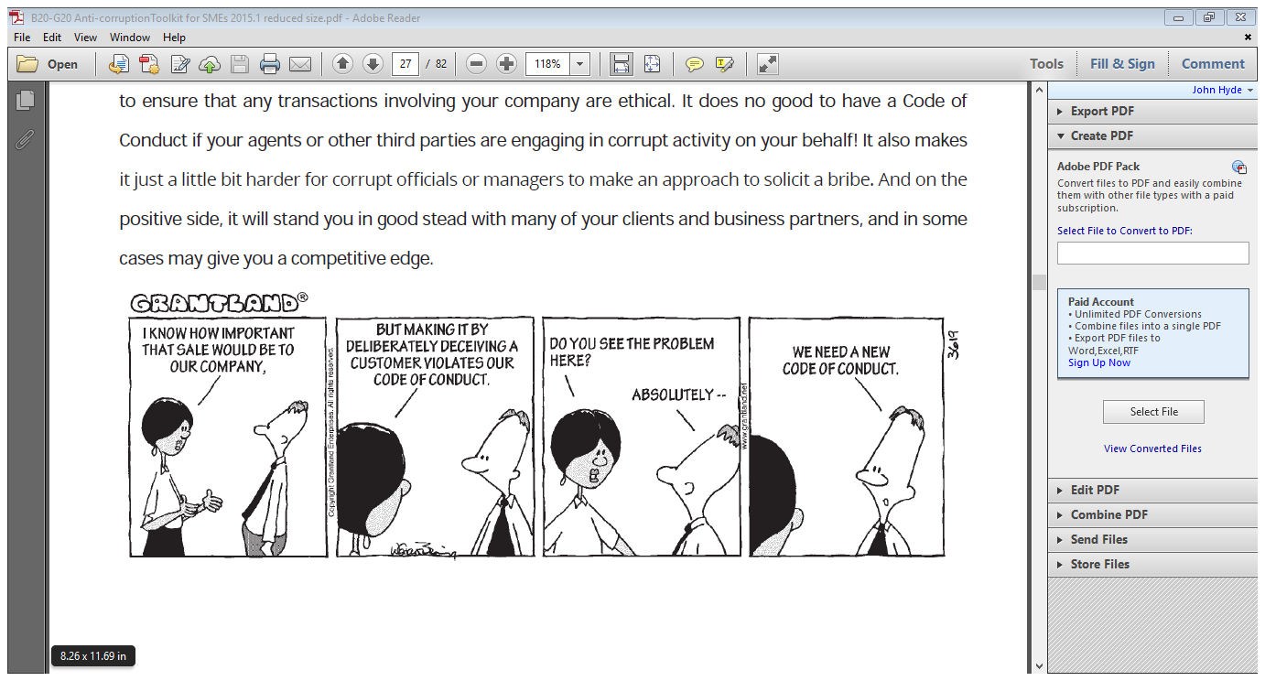

The B20 – G20 anti-corruption education toolkit for Small and Medium Enterprises (SMEs) (includes section on developing Codes of Conduct and is very user-friendly):

..\B20-G20 Anti-corruptionToolkit for SMEs 2015.1 reduced size.pdf

**The Gift and Gratuities Checklist:**

**G**enuine: Is the offer made for reasons of genuine appreciation for something I have done, without any encouragement from me?

**I**ndependent: If I accept it, would a reasonable bystander be confident that I could be

independent in doing my job?

**F**ree: Could I always feel free of any obligation to do something in return for the donor?

**T**ransparent: Would I be comfortable if the gift was transparent to my organisation, colleagues and to the public?

<http://www.southernhealth.nhs.uk/EasysiteWeb/getresource.axd?AssetID=69074>

The OECD-UNODC-World Bank 2013 handbook, Anti-Corruption Ethics and Compliance Handbook for Business, while not intended to create new standards or represent any form of legally binding requirement for businesses, has been developed to serve as a useful, practical tool for companies seeking compliance advice. It brings together, in one reference resource, the major international business guidance instruments and provides real-life case studies from companies on the application of these instruments in practice.

<http://www.unodc.org/documents/corruption/Publications/2013/Anti-CorruptionEthicsComplianceHandbook.pdf>

<http://www.oecd.org/corruption/anti-corruption-ethics-and-compliance-handbook-for-business.htm>

E-learning tool for businesses - a European set of good training videos on ethical dilemmas, including gifts.

<http://thefightagainstcorruption.org/>

Anti-corruption policies and measures of the Fortune Global 500 companies: this provides examples of Codes and policies from the 500 biggest companies in the world.

<http://www.unodc.org/unodc/en/corruption/anti-corruption-policies-and-measures-of-the-fortune-global-500.html>

Center for the Study of Ethics in the Professions in Illinois, lists a directory of many small business organizations’ Codes.

<http://ethics.iit.edu/ecodes/ethics-area/5?title_op=word&title>=

The **Guam Chamber of Commerce** adopts a short Code with a very American cultural text and includes members signing a personal declaration:

**CODE OF ETHICS**

Each member of the Guam Chamber of Commerce ascribes to a Code of Ethics which serves as inspiration for each Member to rise above minimum standards. Through the code, the Chamber proclaims and reaffirms its commitment to the highest ideals of principled free enterprise in the American democratic tradition and in the context of America's outpost in the Pacific Rim. While each Member must find within his own conscience his own measure of right and wrong, as a body, the Chamber adopts this code to encourage and exhort its Members to the common good, within its purposes, and, when necessary, to judge that conduct which is unbecoming a Member of this Chamber.

[Ref. Guam Chamber of Commerce](http://www.guamchamber.com.gu/)

***Member’s Ethics Statement***

*I agree, that as a condition to membership in Chamber of Commerce I will conduct my business in a manner that is ethical, fair, and honest in all dealings with my customers, vendors, associates, employees, and fellow businesses both on and off the Internet. I further agree to promote responsible business practices on the Internet.*

<https://www.chamber101.com/2programs_committee/code_of_cthics/member.htm>

In a conduct guide for public sector boards and committees in 2015, the West Australia Public Sector board recommends that independent boards can present their code in any format and with content they consider best suits your board, as long as it addresses these seven conduct areas:

1. Personal behaviour

2. Communication and official information

3. Fraudulent or corrupt behaviour

4. Use of public resources

5. Record keeping and use of information

6. Conflicts of interest and gifts and benefits

7. Reporting suspected breaches of the code.

<https://publicsector.wa.gov.au/sites/default/files/documents/conduct_guide_for_boards_and_committees_2.pdf> (Page 8)

**Preface to the Code and this e-learning material in national workshops**

PIPSO staff advanced a draft paper[8] on a Code of Conduct, which also contains a very good Preface and some introductory background material. Some key language from this preface and code has been incorporated into the adopted PIPSO Code above. UN-PRAC and PIPSO staff recommended adopting a simpler, stand-alone two-page code as the primary document, and incorporating the Preface/introductory material provided here into an e-learning document and any national workshops. Many of the “facts” and data surrounding corruption change quite rapidly and could detract from the primacy of a Code. A two-page Code can easily be laminated, displayed prominently and be seen as a key document for new members and staff.

**Draft Statement of Commitment which can be incorporated into memberships forms for NPSOs:**

Board members and other experts have different views on the need for members to actually sign a Statement of Commitment to the Code. Each NPSO should discuss this issue and adopt a position. One example is the Guam Chamber of Commerce Member’s Ethics Statement:

*I agree, that as a condition to membership in Chamber of Commerce I will conduct my business in a manner that is ethical, fair, and honest in all dealings with my customers, vendors, associates, employees, and fellow businesses both on and off the Internet. I further agree to promote responsible business practices on the Internet.*

<https://www.chamber101.com/2programs_committee/code_of_cthics/member.htm>

Another is from the Global Organisation of Parliamentarians Against Corruption: the Code is a feature of the Policies Manual which each board member must review and sign after every biennial election.



**Template 1:**

**Statement of Commitment to the _________________ NPSO Code of Conduct**

**To: ____________ NPSO**

**In compliance with the NPSO/PIPSO Code of Conduct, I fully agree (please initial):**

**• If I am charged with corruption, even if I am not guilty, I will stand down from the Board until the matter is resolved;**

**• If I am convicted of corruption, I will resign from the Board and withdraw from my NPSO/PIPSO immediately;**

**• To adhere to the Code, and indicate any potential conflicts of interest or past involvements that might embarrass the NPSO/PIPSO;**

**• If on reflection I feel that my participation on the Board could reasonably risk the reputation of PIPSO, I will resign from the Board, or if I am unsure, I will consult with its Chairperson;**

**• On becoming aware of any risk of negative publicity regarding a purported involvement in corruption or a conflict of interest, I will document the situation and send the information to the NPSO/PIPSO Chair and Executive Director; and**

**• Other than the items declared below, if any, I am not aware of any potential conflicts with the NPSO/PIPSO Code of Conduct.**

**I fully recognize that the application of the Code is not a device to invade my privacy, nor should it be applied in a way that provides the unscrupulous with a weapon with which to undermine the credibility of NPSO/PIPSO members by falsely accusing them of corruption.**

**Sincerely,**

**____________________**

**Template 2:**

**Gifts and benefits**

**The offer of gifts, benefits and hospitality can introduce a personal interest where one may not have existed previously. The Fijian Government has introduced a Gifts policy which precludes public officials from receiving any gift. Officials may receive a gift at a public ceremony, eg food or of cultural value but it must be immediately donated to a charity organisation.**

**Policies you may choose to further explore in your code or associated policies:**

**• whether to include a standing agenda item for all board meetings for the declaration of conflicts of interest**

**• identifying, declaring and managing conflicts of interest (perceived, potential and actual), such as: – examples specific to the board, including relationships with contractors – action required to manage a conflict – reference to any legislation prohibiting decision making in certain circumstances**

**• the offer and acceptance of gifts and benefits, such as:**

**– whether gifts can be accepted at all and when it is not appropriate to accept gifts**

**– gifts that can never be accepted, for example, cash, vouchers or gifts easily converted to cash, or gifts from potential contractors or tenderers for the supply of goods or services to the board or an associated entity**

**– reference to any legislation prohibiting decision making in certain circumstances**

**– the need to record all gifts and benefits accepted or provided by the board or board members in a register.**

**Boards may also wish to record gifts offered by people or organisations but declined by individual members or the board as a whole – the practice of providing guidelines to tenderers and contractors to inform them about the board’s code of conduct and gifts and benefits policy.**

**A simple book recording the nature of the gift, whether it was accepted, its value and any action taken may be sufficient in many cases to ensure transparency as long as the entries are regularly tabled at a board meeting or online.**

**However, where gift-giving becomes an issue, a more robust gifts register, such as the one below, may be required.**

**Further online training support is available from:**

**Gifts, benefits and hospitality - A guide to good practice (Integrity Coordinating Group Western Australia, 2013)**

[**https://icg.wa.gov.au/gifts-benefits-and-hospitality-guide-good-practice**](https://icg.wa.gov.au/gifts-benefits-and-hospitality-guide-good-practice)

Business Conduct for Staff – Interest, Gifts, Hospitality, Sponsorship and Bribery Act Policy (NHS Foundation Trust, 2015)

**Sample register**

**Details of the NPSO representative or authority offered the gift, benefit or hospitality**

Name:

Department:

Job Title:

Name of Donor:

Description of Gift,

Hospitality or Sponsorship Received:

Date Received:

Value of Gift, Hospitality or Sponsorship Received:

(estimated) Under $25 $25 - $50 Over $50

Reason for Gift, Hospitality or Sponsorship:

Details of any contract the donor is interested in securing:

Whether Gift, Hospitality or Sponsorship declined:

Details of any management approval sought before acceptance:

Other: (please specify)

I declare that the gift / hospitality declared or received was entirely consistent with the requirements of _______ NPSO Code of Conduct and that no business decisions have or will be improperly influenced by gifts or advancements nor personal gain obtained.

Signed:

Date:

**http://www.southernhealth.nhs.uk/EasysiteWeb/getresource.axd?AssetID=69074**

**Template 3:**

**Monitoring compliance with your Code**

It may be useful for a NPSO to establish a system for monitoring compliance. Such monitoring activities could include:

• using review processes to assess compliance with the code and adherence to associated policies and guidelines, for example, a review of the board’s gifts register and procurement decisions;

• considering feedback, complaints or issues raised about non-compliance;

• analysing information obtained through stakeholder perception surveys.

**Taking action in response to code issues**

The PIPSO Constitution already addresses “membership matters”. This is probably sufficient to empower the Board and the Council sufficiently to address blatant acts of corruption where a member refused to resign. The Board is already empowered to enact By-laws, so it could consider a more specific By-law addressing: “A breach of the Code of Conduct”. However, as we have seen in recent years, the definition of corruption and misconduct changes over time as communities and stakeholders demand a higher standard of conduct from their office-bearers and representatives. In a small NPSO, the deterrence value of a good Code and the ultimate constitutional power over membership matters may be sufficient without needing to create additional by-laws.

The PIPSO Constitution at Article X gives the power to the Council:

(vii.) Decide on any matters regarding membership that are referred to it by the Board and to approve the termination or suspension of any member.

Article XVI empowers the Board to enact By-laws:

(x.) Adopt, periodically review and amend the By-Laws in accordance with the provisions set out in these articles and the by-laws.Acting on suspected non-compliance involves taking fair and prompt action to prevent and deal effectively with the matters. This creates confidence among board members and employees that the board takes conduct issues seriously and will take action if suspected breaches are reported.

Prior to taking action on suspected breaches, ensure your board has appropriate Constitutional authority to do so and is clear about the correct process to be used for board members or employees.

**Template 4:**

**What are the SDGs?**

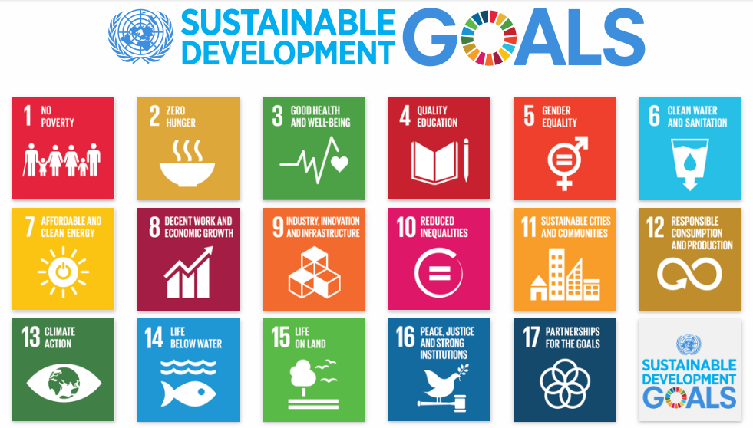

**What are the Sustainable Development Goals?**

**The Sustainable Development Goals (SDGs), otherwise known as the Global Goals, are a universal call to action to end poverty, protect the planet and ensure that all people enjoy peace and prosperity.**

**These 17 Goals build on the successes of the** [**Millennium Development Goals**](http://www.undp.org/content/undp/en/home/sustainable-development-goals/background.html)**, while including new areas such as climate change, economic inequality, innovation, sustainable consumption, peace and justice, among other priorities. The goals are interconnected – often the key to success on one will involve tackling issues more commonly associated with another.**

**The SDGs work in the spirit of partnership and pragmatism to make the right choices now to improve life, in a sustainable way, for future generations. They provide clear guidelines and targets for all countries to adopt in accordance with their own priorities and the environmental challenges of the world at large. The SDGs are an inclusive agenda. They tackle the root causes of poverty and unite us together to make a positive change for both people and planet.**

**Additional activities to be considered by NPSOs when they adopt their Code of Conduct:**

**Review date • [Date the code will be reviewed.]**

Good practice ensures that a periodic review of Codes is undertaken, in keeping with the NPSO’s usual review practices. Eg. Every three years.

Regularly reviewing and updating your code ensures it continues to address current and emerging conduct risks. Your code may not require an update with every review, however, without a review process it may quickly become out-dated. Designate a position or member to review the code as scheduled.

Codes may also need to be reviewed and updated outside scheduled review periods, in response to:

• new or amended legislation or subsidiary legislation;

• changes to board or government policy;

• findings made by integrity agencies that identify risk areas that have not been addressed within your code;

• findings from reviews or feedback from members or employees;

• complaints about how your board manages part or all of its functions.

Not all issues will arise from a deficiency in a code. Some may relate to a lack of knowledge or understanding and this may be better addressed through ongoing discussion about the code and board requirements.

**Raising awareness – promoting your code**

The successful integration of your code into behaviour and action will require ongoing promotion, rather than relying on a once-off induction or training program. You may consider the following strategies to raise awareness.

• Include conduct and integrity expectations in role statements and attach a copy of the code to appointment letters to your board members.

• Incorporate the code of conduct into induction for new board members.

• Introduce your code as an agenda item and minute this introduction.

• Have each board member (and chair) sign the code to confirm they have read it.

• Publish the code on your intranet, have hard copies available and promote your code within any board publications.

• Reference the code in other documents, such as the board charter, statement of intent and strategic plan.

• Reference the code in performance agreements if they are in place and discuss and evaluate conduct expectations during performance management.

• Extend communication about the board and code of conduct to stakeholders including contractors, suppliers and clients.

• Use the code of conduct (and associated policies and guidelines) as the base for your board’s ‘Accountable and ethical decision making’ training program.

• Consider times when reminders may be required, for example, at Christmas when gifts are more likely to be offered to the board and board members.

(Ref: Conduct guide for public sector boards and committees, WA Public Service Commission, 2015)

1. UN-PRAC Phase II Document, Activity Result 3.2.1: Youth, women, business and other regional specific anti-corruption networks supported, and anti-corruption initiatives generated; Activity Result 3.2.2: Regional and country level partnerships on corruption prevention, including institutions, CSOs and businesses, supported
2. <http://www.pipso.org.fj/wp-content/uploads/2016/11/PIPSO-StrategicPlan-31Jan2016.pdf>
3. Status of implementation of Conference resolution 5/6, entitled “Private sector”, UNODC, Item 4, provisional agenda 18 August 2015.
4. Page 17 <https://issuu.com/webmediawebstats/docs/npso_guidlines>
5. <http://www.track.unodc.org/private_sector/Pages/home.aspx>
6. An Anti-Corruption Ethics and Compliance Programme for Business: A Practical Guide (Page 20, 28) <http://www.unodc.org/documents/corruption/Publications/2013/13-84498_Ebook.pdf>
7. <https://www.unodc.org/documents/treaties/UNCAC/E-Learning/English/gifts_hospitality_receiving/index.htm>
8. [Code of Conduct combined-PIPSO.2.17.docx](Code%20of%20Conduct%20combined-PIPSO.2.17.docx)