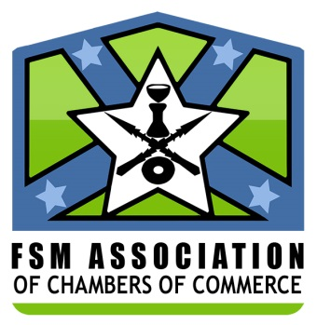
FSM ASSOCIATION
of Chambers of Commerce
Representing the FSM Private Sector
◊
fsmacc.secretariat@gmail.com

REGIONAL CAPACITY BUILDING TRAINING SESSIONS FOR PIPSO MEMBERS
Nadi, Fiji – July 24-26, 2017
LEARNING JOURNEYS ON POLICY ADVOCACY

I OVERVIEW OF FSM PRIVATE SECTOR ORGANIZATIONS—
--FSM Association of Chambers of Commerce (FSMACC)
-- Umbrella private sector organization in FSM
-- Chartered NGO – primary objective -to be a strong advocacy for enhancing private sector growth and development throughout the FSM
-- Board members- 12 – 3 from each of the states chamber of commerce
-- President/Chairman of each state chamber of commerce (SCC) are automatic members
-- Other 2 members are selected/elected from each of the SCCs

--- States Chamber of Commerce-
--Representatives of local businesses/private sector in each state
II. METHODS OR WAYS FSMACC OR SCCs USE TO ENGAGE WITH OUR GOVERNMENTS WITH REGARDS TO POLICY FORMAULATIONS AND CONSULTATIONS
- Direct Participation in legislative public hearings on certain matters/issues, primarily those impacting our private sector;
- Formal meetings with Government leaders;
- Periodic Private Sector/Government Sector Dialogue- invitations to certain government officials as guests to attend scheduled meetings of FSMACC and SCCs;
- Participation at scheduled FSM State/National Leadership Conferences(SNLCs);
- Submission of written comments on certain proposed government legislations/initiatives;
- Passage of resolutions from FSMACC/SCCs to States & National Leaders on pertinent issues impacting the private sector.
III. WHAT WORKS AND WHAT DOES NOT WORK
What Works
- More direct contacts to key government officials- from both Legislative & Executive branches at state and national levels
- Identification of “champions” among government leaders(National and state) for private sector.

What Does Not Work

- Passages of resolutions from FSMACC & SCCs addressing certain issues impacting private sector in the FSM without follow-ups on them.

IV. WOULD THE FSMACC/SCCs DO ANYTHING DIFFERENTLY TO MAKE THINGS MORE EFFECTIVE?
- Formalizing the Involvement of appropriate government officials as ex-offial members on the FSMACC Board and the States Chamber of Commerce general memberships
- Continuous engagement on a regular basis with appropriate government officials on the key issues pertaining to the private sector.
- Political endorsements of candidates for public offices who understand and support our private sector needs/challenges. ???????

